Student worksheet answers

6.1 The universe was studied by early Australians
Pages 140–141

Indigenous astronomers
1 What is a constellation?
A constellation is a group of stars that form a picture in the night sky.
To the people living in the western desert, the emu constellation was part of their calendar. When the emu was running, it was time to hunt emus; and when the emu was sitting, it was time to collect emu eggs.
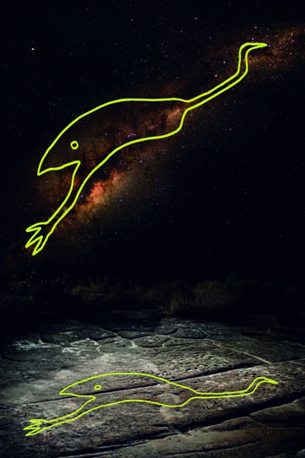
2 Why do you think the information above was important?
It told Indigenous people when different foods were available to eat.
3 In Australia today, most people recognise the group of stars that made up the emu as which galaxy?
The Milky Way

Extend your understanding
Australia's best-known constellation is the Southern Cross. Figure 1 shows how the Boorong people from north-western Victoria saw the Southern Cross. To them, it represented Bunya, who had run away from the evil emu Tchingal and hid in a tree for so long that he turned into a possum. Figure 2 shows that the Ngarrindjeri people who lived on the coast saw the stars of the Southern Cross as a stingray being chased by two sharks.
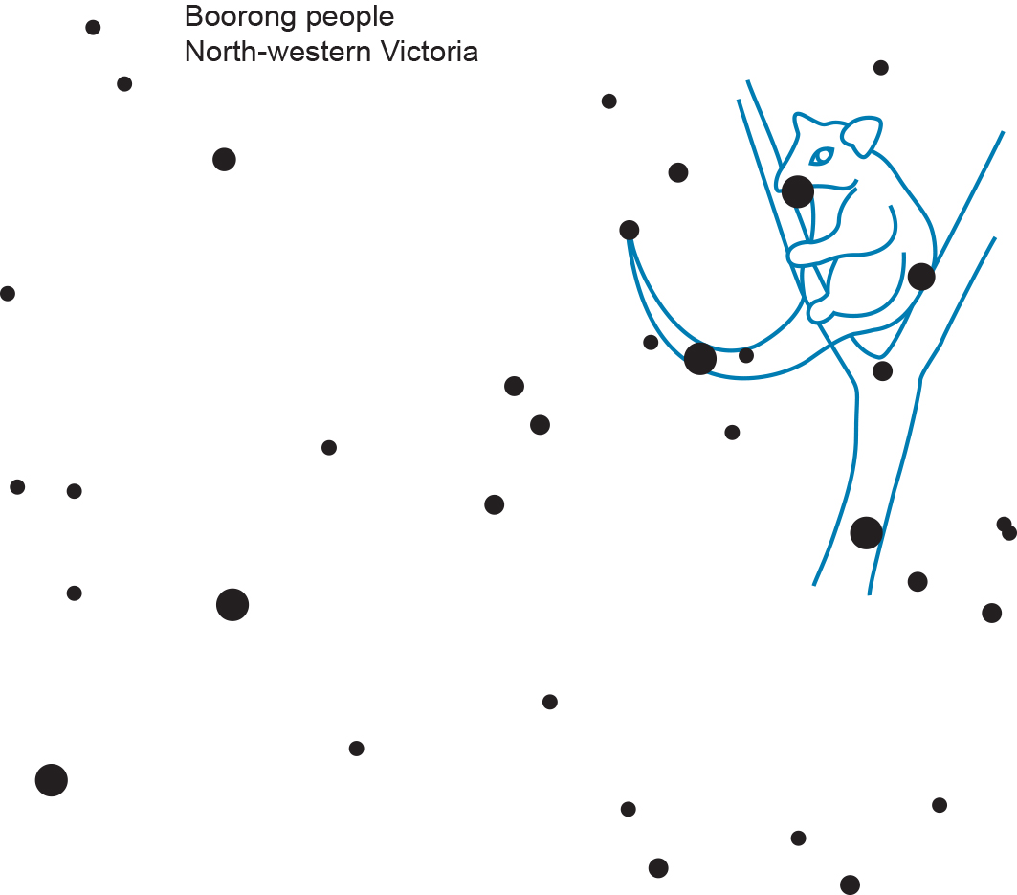 | 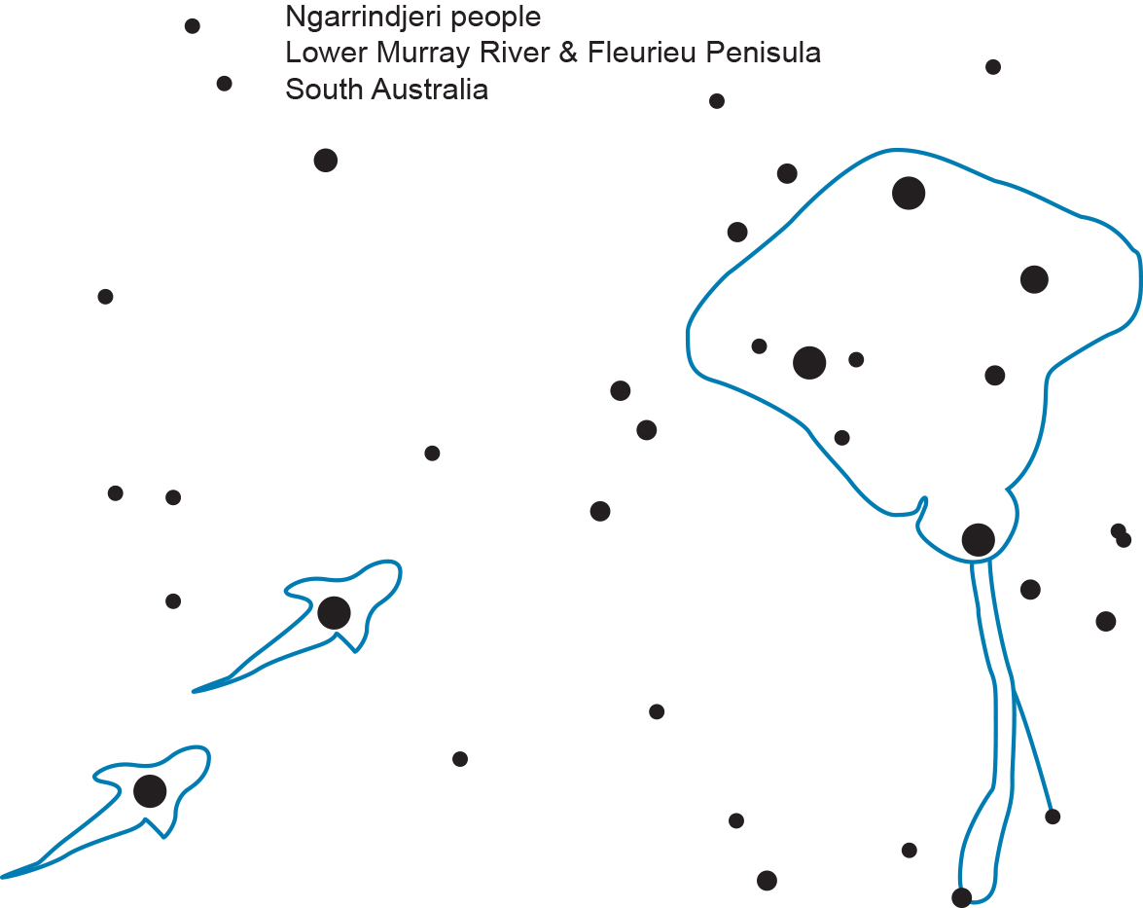
Figure 1 | Figure 2
4 Why do you think that these two different groups of Aboriginal people had different stories for the Southern Cross? (Hint: Use a map to look at the regions where they lived.)
The Boorong and the Ngarrindjeri people lived as separate groups. They each had their own stories that reflected their lives and where they lived. For example, the Ngarrindjeri people lived on the coast and told stories about coastal animals. These two Aboriginal peoples having different views on what they saw in the stars that make up the constellation of the Southern Cross is no different from how we see it. What is seen is related to our cultures.

Student worksheet answers

6.2 The Earth is in the Milky Way
Pages 142–143

Stellar magnitudes, parallax and distances
1 What are stars?
Stars are large balls of gas that undergo nuclear fusion.
2 Why is the apparent magnitude scale for the brightness of stars not suitable for comparing how much light a star is emitting compared with our own Sun?
The apparent magnitude scale is not suitable for comparing the brightness of a star with that of our Sun. This is because it may appear to be bright only because it is relatively close to our Sun, and a star that would be brighter may appear to be dimmer because it is much further away.
3 What does the colour of a star indicate?
The colour of a star is an indicator of its surface temperature. The hotter the surface temperature of a star is, the ‘bluer’ it will be. Conversely, the cooler the surface temperature of a star is, the ‘redder’ it will be.
4 Our Sun has a surface temperature of about 5700 K and an absolute magnitude of 4.77. Use this information to indicate where our Sun would be positioned on the Hertzsprung–Russell diagram below.
As shown on the accompanying diagram, our Sun sits on the main sequence of stars.

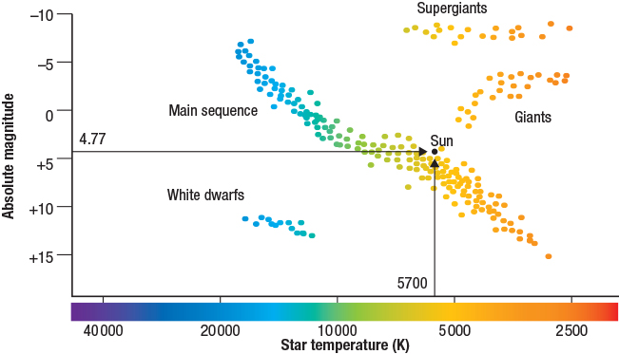

5 What type of star would have an absolute magnitude of –8.0 and a surface temperature of 3500 K?
As shown on the Hertzsprung–Russell diagram, a star with an absolute magnitude of –8.0 and a surface temperature of 3500 K would be a supergiant star.
6 When are the best times to make parallax observations from Earth? Choose from one of the following and then explain your answer.
A Every 12 hours
B Every 24 hours
C Every 6 months
D Every 12 months
Stellar parallax is created by the different orbital positions of the Earth around the Sun. The extremely small shifts in a nearby star’s position are largest at time intervals of six months; hence, the correct answer is C. This gives a baseline distance of 2 AU (2 × 1.50 ×10⁸ kilometres). The parallax angle, p, is considered to be half of this maximum, as shown in Figure 6.5 on page 143 of the Student textbook.
The Sculptor Galaxy, also known as NGC 253, is a spiral galaxy that can be found in the constellation Sculptor. It has a diameter of 70 000 light-years and is at a distance of 11.4 million light-years.
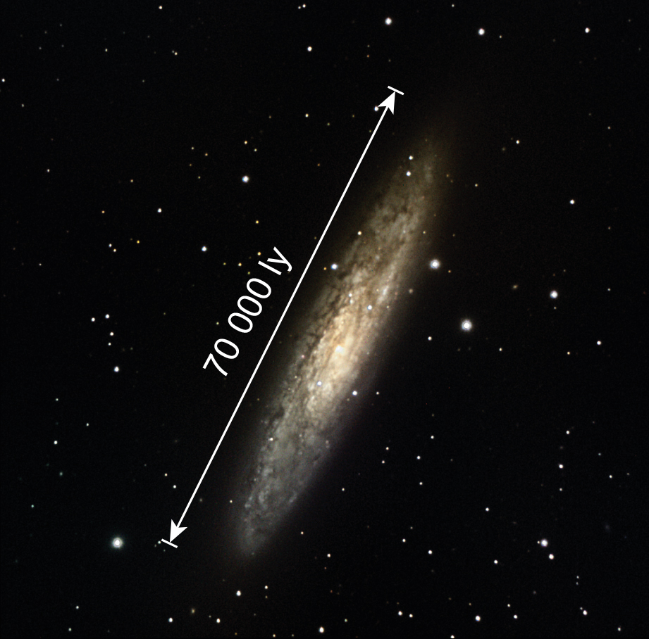
8 What does the term ‘light-year’ mean with respect to the size of the Sculptor Galaxy and how far it is from Earth?
The term 'light-year' with respect to the size of the Sculptor Galaxy means that it takes light 70 000 years to travel from one side of the Sculptor galaxy to the other, and that it takes light emitted by the stars in that galaxy 11.4 million years to reach Earth.

Extend your understanding
Another unit used to measure large distances in space is the parsec. A parsec (pc) is the distance at which a star, as shown in the diagram below, would have a parallax angle equal to one second (1ʺ) of arc.
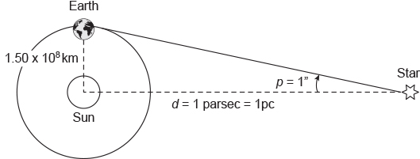
The absolute magnitude M of a star is defined as the apparent magnitude that it would have when viewed at a distance of 10 parsecs (10 pc) from Earth.
Remember that 1 parsec (1 pc) is the distance at which a star would have a parallax angle of one second of arc (1ʺ).
The basic formula that links a star's apparent (m) and absolute (M) magnitude with its distance (d) from Earth is:
$$M=m+5-5 \log_{10}(d)$$
where d is the distance to the star in parsecs (pc).
9 Sirius is the brightest star in the night sky. It has an apparent magnitude of –1.44 and is at a distance of 2.63 parsecs from Earth. Use the formula above and your calculator to work out its absolute magnitude.
M = ?, m = –1.44, d = 2.63 pc
$$M=m+5-5 \log_{10}(d)$$
$$=-1.44+5-5\log_{10}(2.63)$$
$$=-1.44+5-2.10$$
$$=1.46$$
10 Our Sun has an apparent magnitude of –26.8 and is at a distance of 1.50 × 10⁸ kilometres from Earth. Use the formula above and your calculator to show that its absolute magnitude is 4.77.
M = ?, m = –26.8, d = 1.50 × 10⁸ km
$$d=1.50×{10}^{8}÷3.09×{10}^{13} pc$$
$$=4.854×{10}^{-6} pc$$
$$M=-26.8+5-5 \log_{10}(4.854×{10}^{-6})$$
$$=-26.8+5-(-26.57)$$
$$=4.77$$
11 At a distance of 10 parsecs, which star would appear brighter: our Sun or Sirius? Explain your answer.
At a distance of 10 parsecs, Sirius would have an apparent magnitude of 1.46 and our Sun would have an apparent magnitude of 4.77. On the apparent magnitude scale, because the more positive (and the less negative) the number the dimmer the star, our Sun would appear to be less bright than Sirius.

Student worksheet answers

6.3 Stars have a life cycle
Pages 144–145

Stellar evolution
1 Use the wordlist below to correctly identify each of the stages (A to F) in a star's life cycle if it initially has a mass greater than eight solar masses and a core mass greater than three solar masses. Write your answers in the table provided.
Supernova | Red super giant | Gas and dust | Main sequence | Neutron star
White dwarf | Protostar | Planetary nebula | Black hole | Super giant
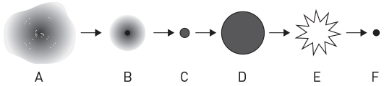
A Gas and dust | D Red super giant
B Protostar | E Supernova
C Main sequence | F Black hole
2 How is a neutron star formed?
Neutron stars are formed when the core from a supernova (exploding star) collapses and the force of gravity causes the remaining protons and electrons to fuse together to form neutrons.
3 Describe the process that is occurring now in our Sun to produce its energy and maintain its stability.
The energy released by the Sun comes from the fusion of hydrogen atoms into helium atoms. This energy forces the gas particles outwards, but the force of gravity pulls them back in. When these two forces are balanced, the star is relatively stable, like our Sun is currently, and it is said to be in hydrostatic equilibrium.
4 Explain what will happen inside, and what will happen to, the Sun when it reaches the end of the main sequence part of its life cycle.
When our Sun runs out of hydrogen for nuclear fusion, it will fuse its helium into heavier elements. This process releases more energy than the nuclear fusion of hydrogen atoms, so there will be a greater outward pressure on the gas particles than the gravitational force pulling them back in. Hence, the Sun will expand and become a red giant star.

Extend your understanding
Astronomers have determined that the centre of our Milky Way galaxy is located in the constellation of Sagittarius, and have also hypothesised that there is a super massive black hole located there – dubbed Sagittarius A*.
5 What evidence have astronomers been able to gather in support of the hypothesis that Sagittarius A* is a super massive black hole? Use the internet to research the answer.
The evidence that astronomers have been able to gather in support of the hypothesis that Sagittarius A* is a super massive black hole is: applying Kepler’s laws and Newton’s law of gravity on the stars orbiting Sagittarius A* give it a mass of 4.31 million times the mass of our Sun, which is much bigger than any known star. There is no light being emitted from the region of space that these stars are orbiting around.
Student worksheet answers

6.4 The galaxies are moving apart
Pages 146–147

Spectra, the Doppler effect and galactic motion
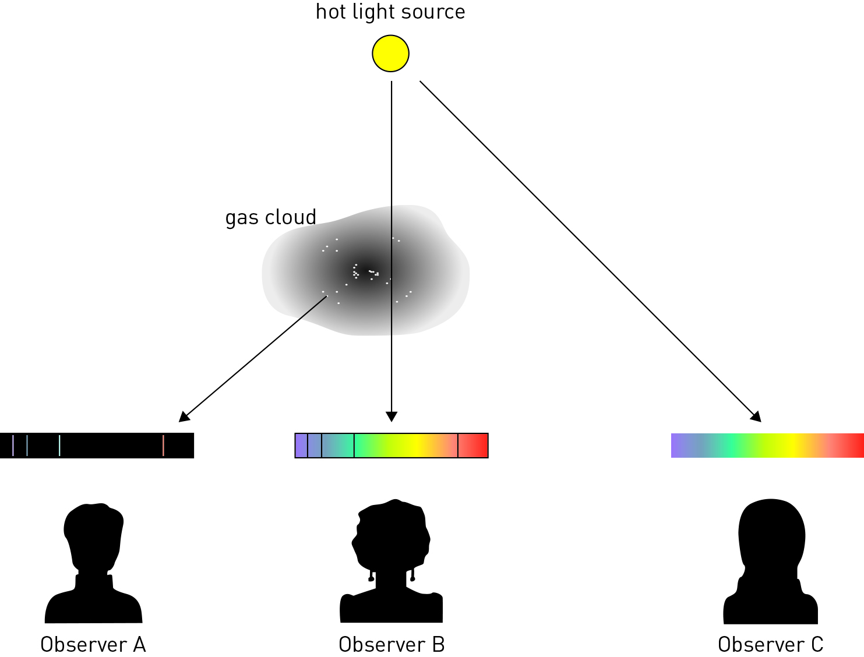

1 In the diagram above, which observer would see:
a a continuous spectrum?
Observer C will see a continuous spectrum.
b an emission spectrum?
Observer A will see an emission spectrum.
c an absorption spectrum?
Observer B will see an absorption spectrum.

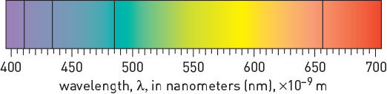  Figure 1 | 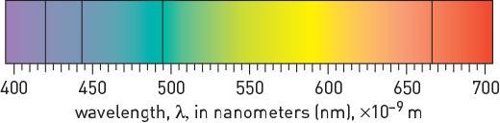  Figure 2
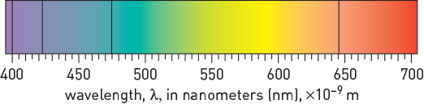  Figure 3 | 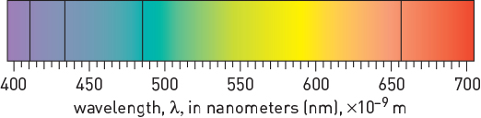  Figure 4
2 Figure 1 shows a spectrum for hydrogen obtained in the laboratory. Which of Figures 2–4 best represents the hydrogen spectrum for a galaxy that is heading towards Earth? Explain your answer.
Figure 3 best represents the hydrogen spectrum for a galaxy that is heading towards us as, due to the Doppler effect, the wavelengths of its absorption lines should be shorter – that is, they have been blue shifted.
3 What did Edwin Hubble discover about distant galaxies that helped provide evidence for the Big Bang theory?
Hubble discovered that further away a galaxy is, the faster it is moving away from us.

Extend your understanding
The Doppler Apparatus (shown below) can be used to understand how the Doppler effect works. To use it, you tie the apparatus to a rope and swing it around in circles. As the apparatus moves in circles, it produces a noise.
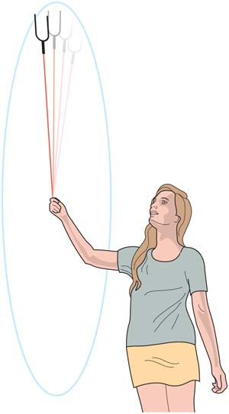
4 What would you expect to happen to the noise from the apparatus as it is swung around in a circle?
The pitch, or frequency, of the sound will increase as the sound waves in front of the apparatus are bunched up and decrease as the sound waves behind the apparatus lengthen.
5 Select an example of where else you may hear the Doppler effect in action. Describe how the effect would work in that situation.
Students’ answers will vary, but they should include a discussion of sound wave length and pitch in relation to the motion of the object.
Student worksheet answers

6.5 The Big Bang theory is supported by evidence
Pages 148–149

Our expanding universe
1 What is the Big Bang theory?
A change in a frequency of a wave as an object moves towards or away from an observer
2 Why might he word ‘bang’ to describe the beginning of the universe be misleading?
Space expanded rapidly and silently; it was not an explosion as the word ‘bang’ suggests.
3 Use the table below to summarise the key evidence for the Big Bang theory.
Aspect of Big Bang theory | Key evidence
Microwave background | Scientists thought that an enormous amount of heat would have been released as part of the Big Bang, and would still exist still 13.7 billion years later. Scientists found this leftover energy existed still as background radiation. This is called cosmic microwave background radiation.
Mixture of elements | As energy cannot be created or destroyed, it stands to reason that the energy released as part of the Big Bang must have been converted into elementary matter. Scientists can see cool spots in the universe as temperature fluctuations, which are consistent with the formation of distant galaxies and old stars.
The universe is changing | Light from distant galaxies takes many years to reach Earth. This means we can see old galaxies that developed millions of years before our own Earth – we are looking back in time. This has given us a timeline consistent with what we know about the Big Bang.
4 Some scientists say that when we examine distant galaxies, we are looking back in time. What do they mean by this?
The light from other galaxies takes a very long time to reach Earth, so scientists can see old galaxies that developed millions of years ago.

Extend your understanding
In 1925 American astronomer Edwin Hubble took a series of images of the nebula M31 (now popularly known as the Andromeda galaxy) and, on comparing them, discovered a Cepheid variable star that he called V1. He measured V1’s period of pulsation to be 31.4 days.  Since a Cepheid variable star’s period of pulsation determines its variation in magnitude, as discovered by American astronomer Henrietta Leavitt, Hubble was then able to calculate how far away V1 was from Earth. He did this by measuring V1’s variation in brightness and, on comparing this with the absolute variation predicted by the relationship discovered by Henrietta Leavitt, Hubble calculated that M31 was 285 000 parsecs away from Earth – this led to it being classified as a galaxy in its own right, and not part of our Milky Way galaxy. The universe had suddenly become a very large place!  In 1929 Hubble published a paper that showed the results of his investigation of the relationship between a galaxy’s radial velocity (derived from its Doppler shift) and its distance from Earth. |   Edwin Powell Hubble
Hubble’s data
Object  name | Distance  (Mpc) | Velocity  (km/s) |  | Object  name | Distance  (Mpc) | Velocity  (km/s)
SMC | 0.032 | +170 |  | NGC 3627 | 0.9 | +650
LMC | 0.034 | +290 |  | NGC 4826 | 0.9 | +500
NGC 6822 | 0.214 | –130 |  | NGC 5236 | 0.9 | +500
NGC 598 | 0.263 | –70 |  | NGC 1068 | 1.0 | +920
NGC 221 | 0.275 | –185 |  | NGC 1055 | 1.1 | +450
NGC 224 | 0.275 | –220 |  | NGC 7331 | 1.1 | +500
NGC 5357 | 0.45 | +200 |  | NGC 4258 | 1.4 | +500
NGC 4736 | 0.5 | +290 |  | NGC 4151 | 1.7 | +960
NGC 5194 | 0.5 | +270 |  | NGC 4382 | 2.0 | +500
NGC 4449 | 0.63 | +200 |  | NGC 4472 | 2.0 | +850
NGC 4214 | 0.8 | +300 |  | NGC 4486 | 2.0 | +800
NGC 3031 | 0.9 | –30 |  | NGC 4649 | 2.0 | +1090
Note: 1 Mpc = 1 million parsecs = 1.0 × 10⁶ pc
5 Using the data in the above tables, plot a graph of radial velocity (km/s) against distance (Mpc) on the axes provided.

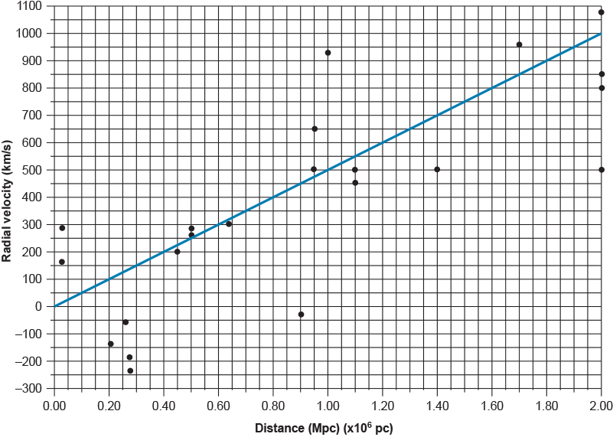
6 What does the general trend of the data suggest about what is happening in the universe? Explain your answer.
The general trend of the data suggests that the universe is expanding. The evidence that supports this is that the further away a galaxy is, the faster it is moving away from us.
7 Some of the radial velocities in Hubble’s data were negative. What does this tell us about their motion? Can you think of a reason why this might be so, given that the radial velocities of all of the other galaxies have positive values?
The galaxies with negative radial velocities are moving towards us, not away from us. Relatively speaking, they are all ‘close’ to us, so the reason why they are moving towards us could be (and is) that they are gravitationally bound together as a group.

Student worksheet answers

6.6 Technology aids cosmological research
Pages 150–151

Cosmological research
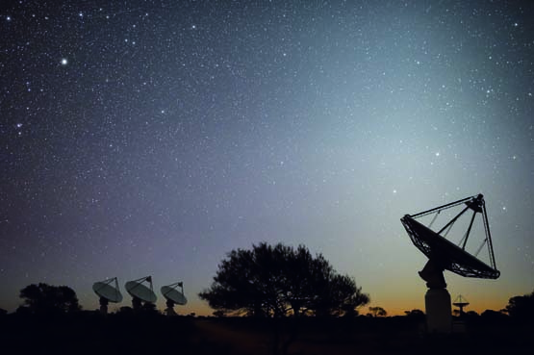
1 What is the name of the $160 million dollar project being built in Western Australia?
Australian Square Kilometre Array telescope
2 How does a radio astronomy telescope work?
The radio astronomy telescope uses many large antenna dishes that survey areas of the sky. The dishes pick up radio waves that are emitted from objects in space, sending back data in numbers that computers are then able to turn into pictures.
3 What are some of the things that can be photographed with the new telescope?
Millions of new galaxies, black holes and things in the very distant universes that no one has ever seen before.
4 Consider the article ‘Australian Square Kilometre Array telescope takes shape in WA outback’ on page 150 of the Student book and answer the following questions.
a What is the article about?
The construction of the Australian Square Kilometre Array telescope (a radio astronomy telescope) in Western Australia
b What does the author of this text want you to understand?
The construction of the Australian Square Kilometre Array telescope (a radio astronomy telescope) in Western Australian, what scientists can get from the telescope, how that information will be used, how much the telescope can ‘see’, the funding for the project and why it is important
c Why do you think the author used quotes from an expert, in this case Dr Schinkel?
The quotes offered an insight into the real-life scientists’ work. People can also feel that an article has more credibility and can be trusted if experts’ opinions and quotes are used.

Extend your understanding – what is dark matter?
Since the prediction of its existence over 40 years ago the mystery of, and ability to detect, dark matter has escaped the world's best physicsts. It is thought that these invisible particles are everywhere – constantly passing through us and the Earth – yet they provide the gravtitational pull that helps hold the galaxies together.
In the western Victorian town of Stawell, the search for dark matter is about to head underground in a gold mine.
Read the following articles and then answer the questions below:
• Bridie Smith, ‘Hunt for dark matter sends scientists underground in a Victorian goldmine’, The Sydney Morning Herald [online], 12 June 2016, <www.smh.com.au/technology/sci-tech/scientists-hope-to-strike-gold-in-global-hunt-for-dark-matter--at-the-bottom-of-a-stawell-mine-20160609-gpf14p.html>.
• Lisa Clausen, ‘Digging for dark matter’, SBS Science [online], 27 September 2016, <www.sbs.com.au/topics/science/fundamentals/feature/digging-dark-matter>.
5 What are the hypothesised properties of dark matter, and how were these properties assumed?
Dark matter is so called because it cannot be seen – it does not interact with light or any other form of electromagnetic radiation. It rarely interacts with other particles of matter, yet it provides the additional gravitational force needed to hold galaxies together. Its existence has been inferred from its effects on visible matter and the gravitational lensing of light emitted from distant galaxies.
6 Why do the scientists searching for dark matter want to set up a laboratory deep underground?
Scientists want to set up dark matter detectors underground because the Earth's rocky crust blocks most of the cosmic radiation that strikes the Earth every second as it moves through space.
7 What are the features of the gold mine in Stawell that make it a suitable site for a dark matter laboratory?
The features of the gold mine in Stawell that make it a suitable site for a dark matter laboratory are:
• It is 1 kilometre underground, and the volcanic rock surrounding the lab will block out most of the cosmic radiation that bombards the Earth every second.
• The volcanic rock surrounding the laboratory has very low levels of radioactivity.
• Access to the site proposed for the laboratory is by a series of ramps, not shafts, so it can be reached by car/truck. This makes it relatively easy to ship in the equipment required for the dark matter detector and laboratory modules.

